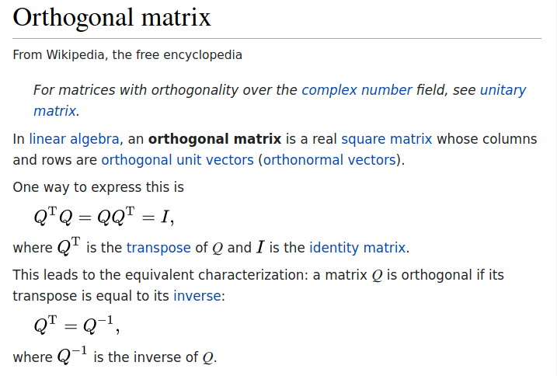

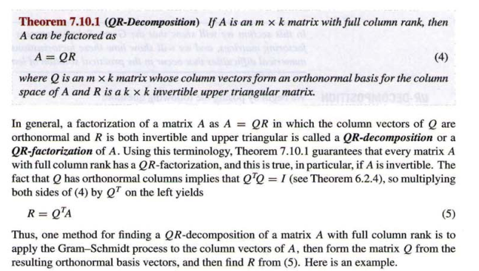

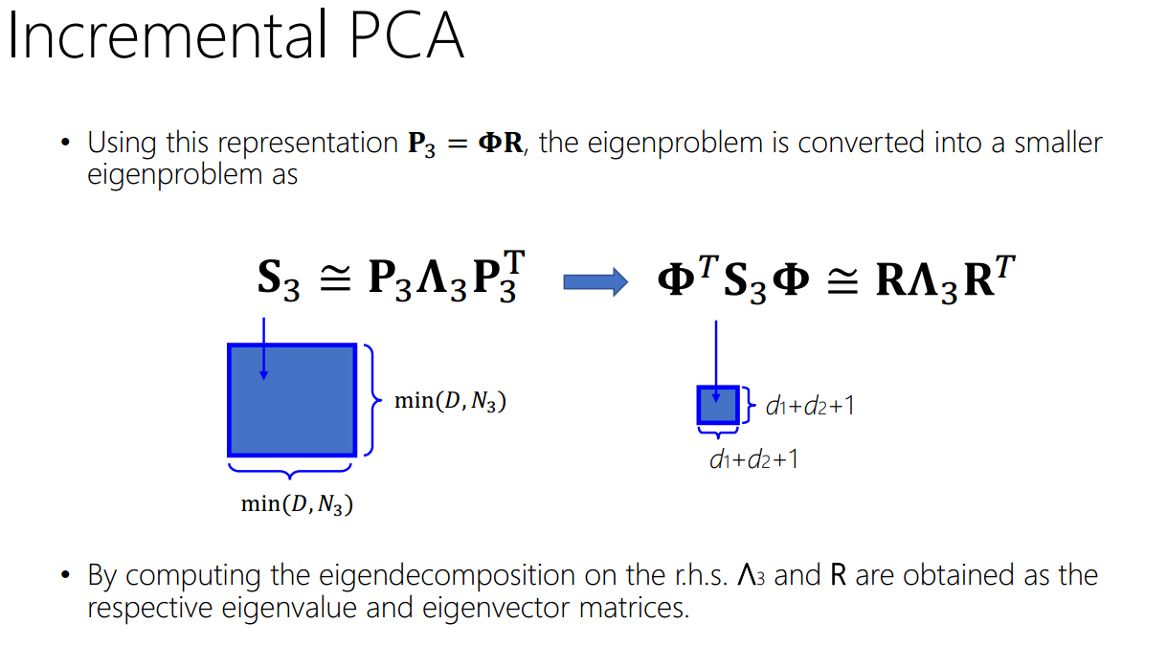

Explain:
d1, d2 are the number of the eigenvectors stored in P1 and P2

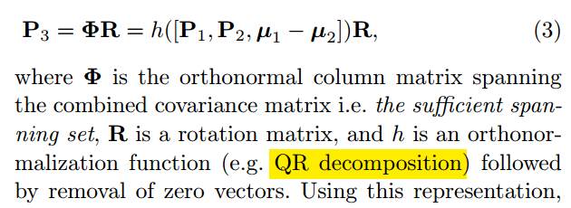

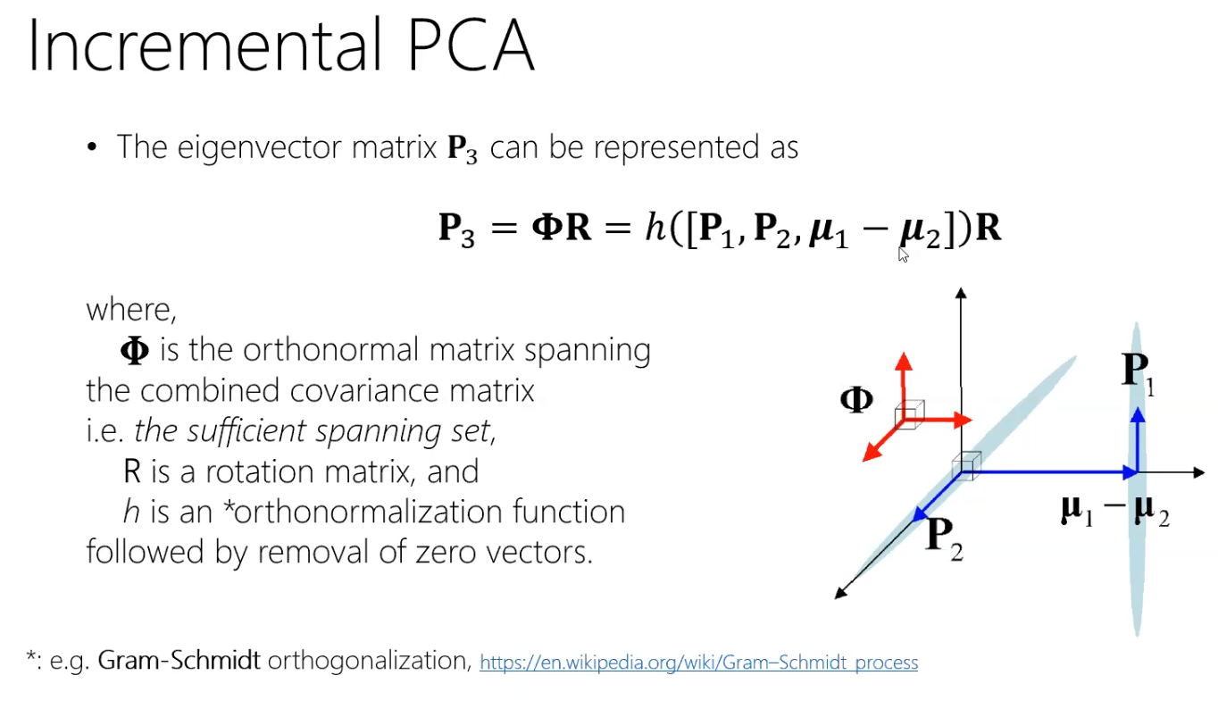

P1,P2, u1-u2 forms the spanning vector set for P3, that means every points in P3 can be represented by a combine of vectors in P1,P2, u1-u2

but these vectors are not orthogonal to each other, and they are not normalized, so we need to do is Gram-Schmidt orthogonalization

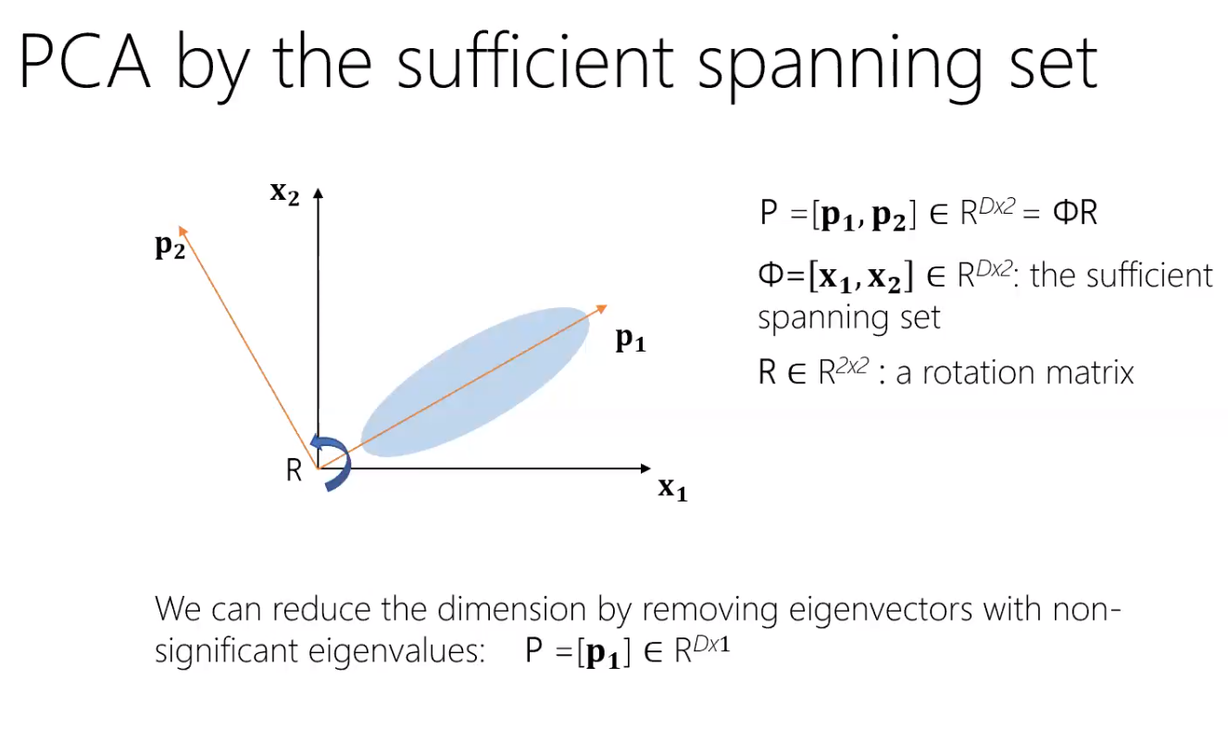
out purpose of incremental PCA is to save time, so after merging 2 PCA models, we need to remove non-important eigenvectors. Each time we merge two PCA models, we need to remove some non-important eigenvectors and just keep the most important eigenvectors.

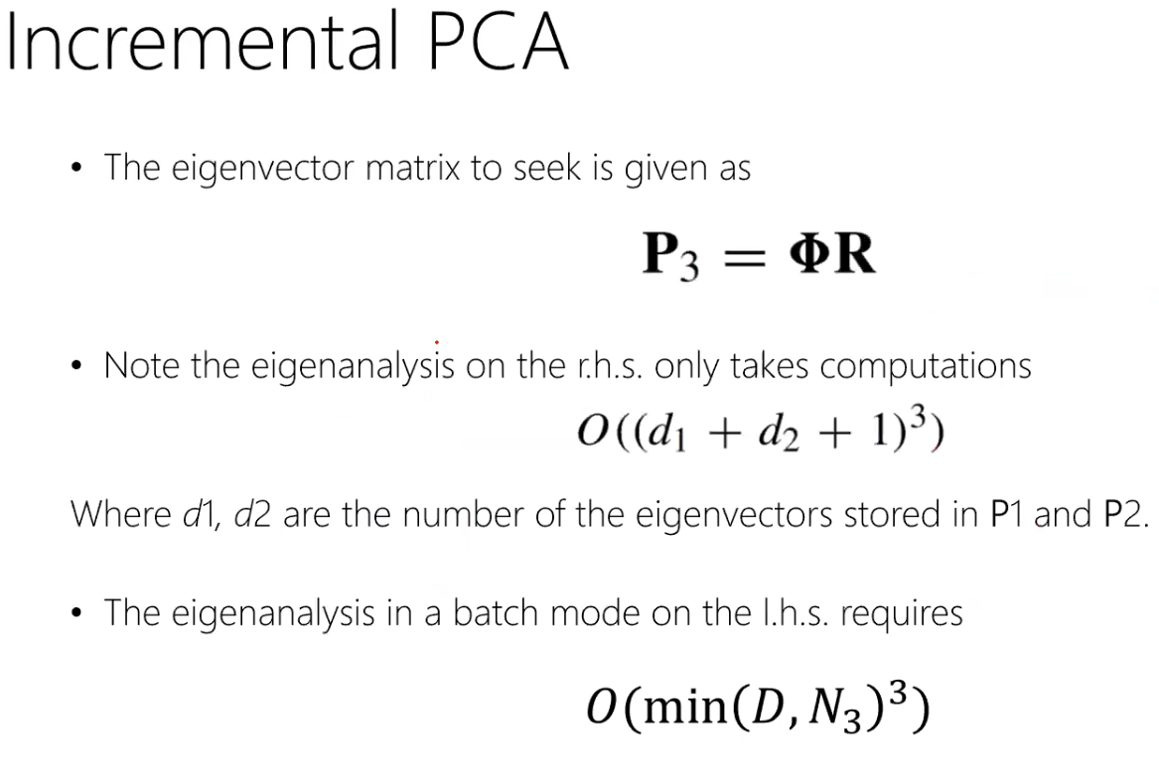

If we keep d1,d2 large, then the complexity of the computation is large. So,we just need to keep the most important eigenvectors.

